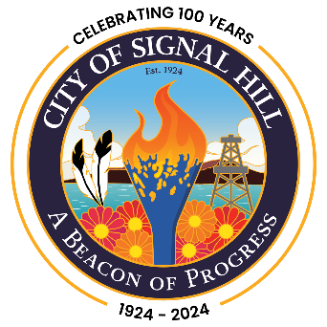

City of Signal Hill

2175 Cherry Avenue Signal Hill, CA 90755-3799

NOTICE OF MEETING CANCELLATION
SIGNAL HILL CITY COUNCIL

NOTICE IS HEREBY given that the Regular Meeting of the Signal Hill City Council scheduled for Tuesday, August 13, 2024, has been canceled.

The next Regular Meeting is scheduled for Tuesday, August 27, 2024 at 7:00 p.m.

For further information, contact the Office of the City Clerk at (562) 989-7305.

All interested persons are hereby invited to attend.

Daritza Gonzalez
City Clerk

Posted this 26th Day of July, 2024.

