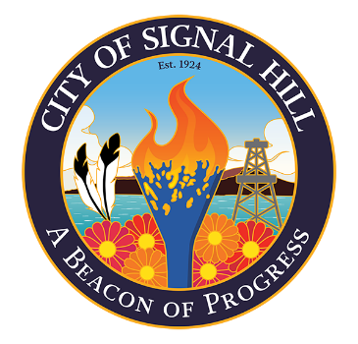

City of Signal Hill

2175 Cherry Avenue Signal Hill, CA 90755-3799

NOTICE OF CANCELLATION

CITY OF SIGNAL HILL
PLANNING COMMISSION

REGULAR MEETING OF DECEMBER 17, 2024

NOTICE IS HEREBY GIVEN that the Signal Hill Planning Commission meeting scheduled for Tuesday, December 17, 2024, is adjourned to the Regular Meeting on Tuesday, January 21, 2025, at 7:00 p.m.

For further information, contact Community Development at (562) 989-7340.

____________________
Colleen T. Doan
Commission Secretary

Posted this 13th day of December, 2024.

