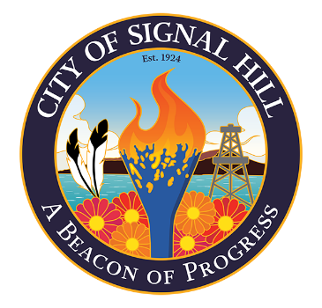

City of Signal Hill

2175 Cherry Avenue Signal Hill, CA 90755-3799

NOTICE OF CANCELLATION

CITY OF SIGNAL HILL
PLANNING COMMISSION

REGULAR MEETING OF FEBRUARY 18, 2025

NOTICE IS HEREBY GIVEN that the Signal Hill Planning Commission meeting scheduled for Tuesday, February 18, 2025, is adjourned to the Regular Meeting on Tuesday, March 18, 2025, at 7:00 p.m.

For further information, contact Community Development at (562) 989-7340.

____________________
Colleen T. Doan
Commission Secretary

Posted this 13th day of February, 2025.

