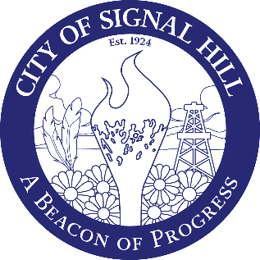

City of Signal Hill

2175 Cherry Avenue Signal Hill, CA 90755-3799

September 5, 2025

NOTICE OF CANCELLED REGULAR MEETING

CITY OF SIGNAL HILL
PLANNING COMMISSION

Tuesday, September 16, 2025

The Regular Meeting of the Planning Commission of the City of Signal Hill scheduled for Tuesday, September 16, 2025 has been cancelled.

For any questions and/or concerns, please contact
Community Development at 562-989-7340.

Thank you for your interest in the City of Signal Hill!

